Case Against Reuters Journalists in Myanmar Moves to Trial
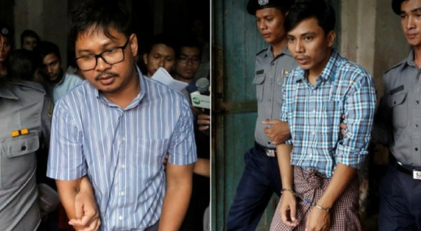
The judge’s decision to charge the reporters with obtaining state secrets dashed any lingering hope that the reporters might be freed without having to go on trial. The reporters, U Wa Lone, 32, and U Kyaw Soe Oo, 28, face up to 14 years in prison under Myanmar’s colonial-era Official Secrets Act, and their case had been in a pretrial phase since their arrest in December.
The New York Times 7.9.18
https://www.nytimes.com/2018/07/09/world/asia/reuters-journalists-myanmar-trial.html?rref=collection%2Fsectioncollection%2Fbusiness-media&utm_source=Listrak&utm_medium=Email&utm_term=Case+Against+Reuters+Journalists+In+Myanmar+Moves+To+Trial&utm_campaign=Sun+Valley+Preps+For+Heatwave%2c+Heavyweights
Image credit:
http://images.wionews.com/styles/photo_image_size_1170x645_/s3/photoimages/Untitled%20design%20%283%29_84.jpg

