Cate Blanchett to Develop, Direct Female-Led TV Series
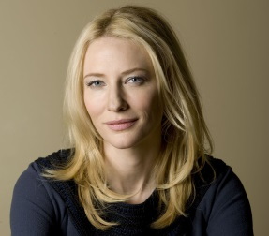
Academy-Award-winning actor Cate Blanchett is moving behind the camera to develop and direct a new series for Australian television. "Stateless" is based on the true story of Cornelia Rau, who "escaped a frightening cult only to be trapped in a bizarre labyrinth of psychiatric and legal systems," Screen Australia said.
Variety 7/20/15
http://variety.com/2015/tv/asia/cate-blanchett-to-direct-tv-series-stateless-1201544440/

