CBS and Viacom Reunite In Merger
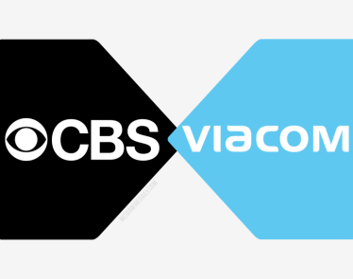
The long-awaited deal between the two media giants puts some of the biggest brands in entertainment back under one corporate banner. Those brands include CBS' broadcast network, the streaming service CBS All Access, movie studio Paramount and cable networks like Showtime, MTV, Nickelodeon, BET and Comedy Central.
CNN Business 8.13.19
https://edition.cnn.com/2019/08/13/media/cbs-viacom-merger/index.html?utm_source=CJR+Daily+News&utm_campaign=2a1cbb6d92-EMAIL_CAMPAIGN_2018_10_31_05_02_COPY_01&utm_medium=email&utm_term=0_9c93f57676-2a1cbb6d92-174383521
Image credit:
https://dev.competitionpolicyinternational.com/wp-content/uploads/2016/12/CBS-AND-VIACOM-MERGER.png

