CEOs Urge Congress to Expand Gun Background Checks
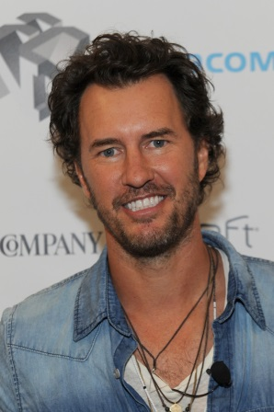
Blake Mycoskie, founder of TOMS shoes, supports causes like access to clean water and eye care in poor countries. But embracing something as controversial as gun control is different. He says his board of directors debated whether he should engage on a political issue unrelated to their business.
National Public Radio 2.25.19
https://www.npr.org/2019/02/25/697839273/ceos-urge-congress-to-expand-gun-background-checks
Image credit:
http://www4.pictures.zimbio.com/gi/Fast+Company+Innovation+Festival+Creativity+QIC0yytnswgx.jpg

