Charter Adds $1M To Digital Education Program
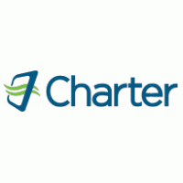
Charter Communications will earmark another $1 million for its 2022 Spectrum Digital Education program to support broadband education and training for nonprofit and community organizations. Since its 2017 introduction, the initiative has raised $8 million to aid 99 groups and more than 95,000 people.
Next TV 5/17/22
https://www.nexttv.com/news/charter-commits-another-dollar1-million-to-spectrum-digital-education-initiative?utm_source=SmartBrief&utm_medium=email&utm_campaign=3E572E13-3FBC-11D5-AD13-000244141872&utm_content=B7303DD9-3FF3-4730-9940-2B442B155D42&utm_term=a25693a1-51b6-4112-bde4-56bd420e983f

