Charter Brings Community Assist To 20 New Cities
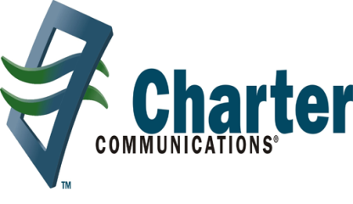
Charter Communications will contribute $30 million to expand its Spectrum Community Assist philanthropic project to 20 more markets across 14 states this year as part of a five-year plan to renovate community centers and support job training. The company introduced the program in five markets during 2021.
Next TV/Multichannel News 4.4.22
https://www.nexttv.com/news/charter-launches-spectrum-community-assist-in-20-new-markets?utm_source=SmartBrief&utm_medium=email&utm_campaign=3E572E13-3FBC-11D5-AD13-000244141872&utm_content=EC7CB38A-6BE4-4B12-9E88-9D2971707841&utm_term=a25693a1-51b6-4112-bde4-56bd420e983f

