Charter Lands $1.2B From FCC to Support Rural Broadband
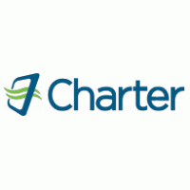
A dozen cable-related companies won Rural Digital Opportunity Fund money in the reverse auction's first phase. Charter Communications will get $1.2 billion of the $9.2 billion total that the Federal Communications Commission is making available for rural broadband expansion, and will serve the most locations of any bidder.
Light Reading 12.7.20
https://www.lightreading.com/opticalip/fttx/charter-tops-us-cables-rdof-take/d/d-id/765946

