Chicago Stations Slam Automakers Over Removal Of AM
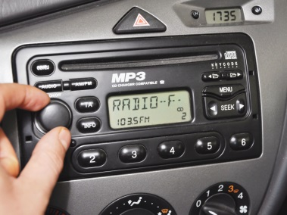
Radio stations in Chicago are criticizing auto manufacturers over the trend of removing AM radio from dashboards in new vehicles, with WCKG-AM threatening to boycott advertisements by Ford or Ford dealers over the move. While some AM stations make content available to listeners over digital streaming platforms, others say their programming would be difficult to reproduce on another medium.
Axios/Chicago 4.2.23
https://www.axios.com/local/chicago/2023/04/02/am-radio-electric-vehicles-chicago
image credit:
http://www.wikihow.com/images/a/af/Best-Enjoy-Your-Car-Radio-Step-5.jpg

