Chicago Takes Aim at Streaming Services with "Cloud Tax"
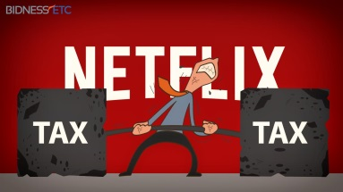
Chicago last week enacted a "cloud tax" of 9% on "electronically delivered amusements," including streaming music and video services. The move is seen as "a response to an increasingly difficult reality for cash-strapped cities, particularly as online services start to take a bite out of the businesses in the urban center," writes Russell Brandom.
TechHive 7/1/15
http://www.techhive.com/article/2942606/cloud-tax-jacks-up-netflix-bills-in-chicago.html

