China Slashes Kids’ Gaming Time to Just Three Hours a Week
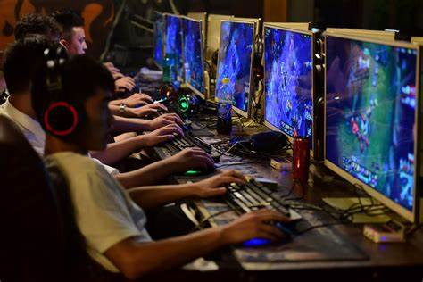
Gaming platforms from Tencent Holdings Ltd. to NetEase Inc. can only offer online gaming to minors from 8 p.m. to 9 p.m. on Fridays, weekends and public holidays, state news agency Xinhua reported, citing a notice by the National Press and Publication Administration. The new rules are a major step up from a previous restriction set in 2019 of 1.5 daily hours most days.
Bloomberg 8.30.21
https://www.bloomberg.com/news/articles/2021-08-30/china-limits-minors-to-just-three-hours-of-online-gaming-a-week
Image credit:
https://www.bing.com/images/search?view=detailV2&ccid=8nkNeV10&id=BF5CAF87EFDF94FBE4D883A02E03E42284F03141&thid=OIF.9Wx8CDXhinlP7aK02TO8pQ&mediaurl=https%3a%2f%2fwww.gameaware.com.au%2fwp-content%2fuploads%2fmerlin_142714389_f4fefec4-d29f-460f-81ab-c795121fa833-superJumbo.jpg&cdnurl=https%3a%2f%2fth.bing.com%2fth%2fid%2fR.f2790d795d74a0e576c34ef6b39c8286%3frik%3d%26pid%3dImgRaw%26r%3d0&exph=1366&expw=2048&q=chinese+gaming+law&simid=94379136186&FORM=IRPRST&ck=F56C7C0835E18A794FEDA2B4D933BCA5&selectedIndex=10&ajaxhist=0&ajaxserp=0

