China Spreads Propaganda to U.S. on Facebook, a Platform It Bans at Home
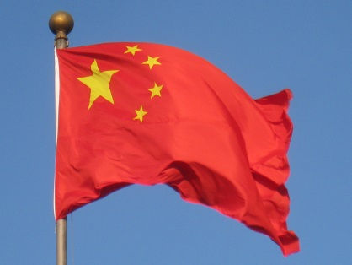
Each quarter, China’s government, through its state media agencies, spends hundreds of thousands of dollars to buy Facebook ads, according to a person with knowledge of those deals, who was unauthorized to talk publicly about the company’s revenue streams.
The New York Times 11.8.17
https://www.nytimes.com/2017/11/08/technology/china-facebook.html?utm_source=API+Need+to+Know+newsletter&utm_campaign=7120aba006-EMAIL_CAMPAIGN_2017_11_10&utm_medium=email&utm_term=0_e3bf78af04-7120aba006-31697553

