China Creates Rules To Protect Young Internet Users
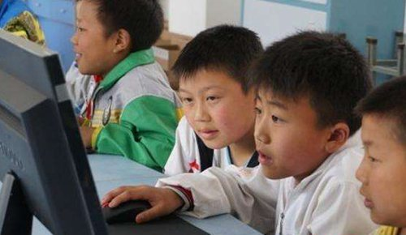
China has issued its first rules designed to protect the "physical and mental health" of its tens of millions of internet users under the age of 18. The onus will be on tech companies and schools to protect young users from harmful internet content and try to prevent addiction, with the rules going into effect Jan. 1.
South China Morning Post (Hong Kong) 10/25/23
https://www.scmp.com/news/china/politics/article/3239155/chinas-new-cyber-safety-rules-protect-minors-puts-burden-internet-and-tech-firms-authorities-and
Image credit:
https://thechinaproject.com/wp-content/uploads/2020/05/Chinese-child-on-internet.jpg

