CNN Error Is Its Latest Journalistic Mishap
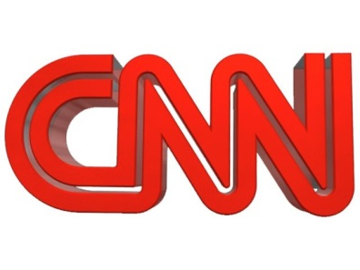
CNN was forced to correct a key error in a story about the Trump campaign and access to hacked Democratic National Committee emails on Friday, extending a run of high-profile media mistakes.
Politico 12.11.17
https://www.politico.com/story/2017/12/08/cnn-trump-error-journalism-287914

