Coca-Cola Unveils Zero Sugar Byte In Fortnite
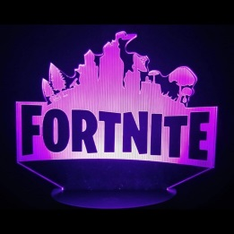
Coca-Cola and PWR are creating a Fortnite Pixel Point Island to advertise Zero Sugar Byte, the "pixel-flavored" second entry in Coca-Cola's Creations product line. The metaverse experience offers four pixel-based mini-games that encourage players to work together.
Marketing Dive 4/4/22
https://www.marketingdive.com/news/coca-cola-coke-byte-pixel-new-flavor-gamers-fortnite/621503/

