Coca-Cola Pulls Offensive Sprite Ad in Ireland
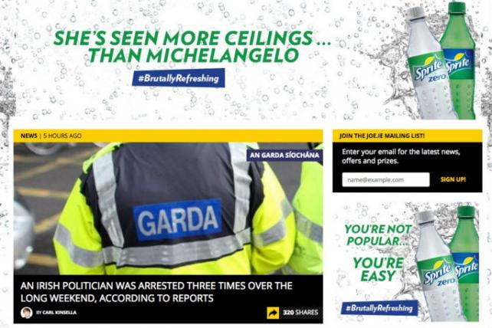
Coca-Cola Co. has apologized for a blatantly sexist Sprite online ad that ran on Irish men's lifestyle site JOE.ie as part of the soft drink's irreverent #BrutallyRefreshing campaign. Lines such as "She's seen more ceilings than Michelangelo," "You're not popular, you're easy" and "A 2 at 10 is a 10 at 2!" shocked consumers, who took to social media to vent their anger.
Advertising Age 8.4.16
http://adage.com/article/global-news/coca-cola-pulls-sexist-sprite-ad-ireland/305323/

