Cognitive Systems to Sharpen Consumer Engagement
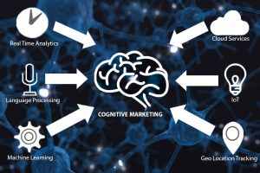
IBM's Rashmy Chatterjee maintains that the future of business lies in cognitive systems. In an interview, she explains that these are "systems that use data and analytics to understand, learn and make informed choices or recommendations" and also explains how the systems can be used in marketing to build a knowledge base about customers and others.
Forbes 10/30/17
https://www.forbes.com/sites/vivianrosenthal/2017/10/30/ibm-north-american-cmo-on-our-cognitive-future/#1029d28b7be2
Image credit:
http://digitalmarketingstrategy.ie/wp-content/uploads/2016/11/Components-of-Cognitive-Marketing-300x200.jpg

