College Students came up with a Fix for Fake News
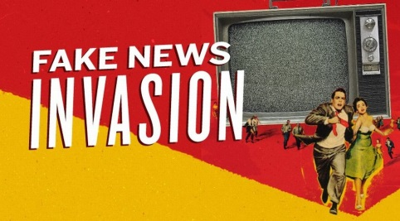
Four students built a Chrome browser extension that tags links in Facebook feeds as verified or not verified. Where a post appears to be false, the plug-in will provide a summary of more credible information on the topic online. A small blue box in the upper right-hand corner of the screen says either "verified" or "not verified." They've called it FiB.
Chicago Tribune 11.23.16
http://www.chicagotribune.com/bluesky/technology/
image source:
http://www.snopes.com/wordpress/wp-content/uploads/2016/01/snopes-fake-news-sites.jpg

