Study: Live Programming Dominates College Students' TV Time
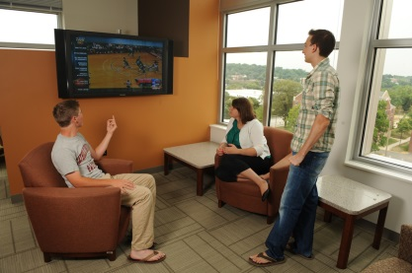
Data collected by Comcast through its Xfinity on Campus service show that 44% of TV consumption by college students between January and June 2018 was live. The most-watched days were Sunday and Thursday, while sports was among the most-watched programming, the data show.
Broadcasting & Cable 9/13/18
https://www.broadcastingcable.com/news/college-kids-give-passing-grade-to-live-tv-comcast
Image credit:
http://housing.cua.edu/res/images/student%20life/residents-watching-tv-opus-1.JPG

