Comcast Closes $3.8B DreamWorks Deal
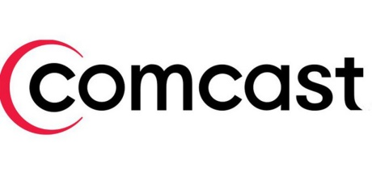
Comcast on Monday announced that it closed the $3.8 billion acquisition of DreamWorks Animation, which will join the Universal Filmed Entertainment Group. DWA stockholders will be paid $41 in cash per share, and analysts believe the acquisition will help the company become more competitive with companies such as Disney and Time Warner.
Variety 8/22/16
http://variety.com/2016/film/news/comcast-completes-dreamworks-animation-purchase-1201842240/

