Comcast's NBCU Combines Broadcast, Cable Divisions
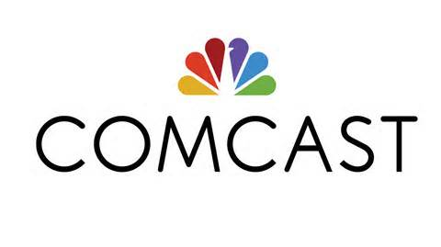
Comcast-owned NBCUniversal has unified its cable and broadcast television divisions with the Peacock service to form NBCUniversal Television and Streaming, with Mark Lazarus in charge. Cesar Conde, chairman of NBCU's international group, will run another expanded group that combines MSNBC, CNBC and NBC News, and current NBC News Chairman Andy Lack will depart.
Variety online 5.4.20
https://variety.com/2020/tv/news/nbcuniversal-restructuring-jeff-shell-mark-lazarus-cesar-conde-andy-lack-1234597407/

