Sources: Comcast, Disney Interested in Sky Ownership
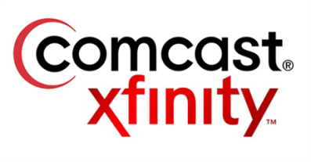
Comcast is interested in acquiring European cable provider Sky, which is contributing to its decision to pursue the purchase of 21st Century Fox assets, a source says. Disney also is interested in Fox assets outside the US, including Sky, which is one of Europe's largest pay-TV providers.
Bloomberg 12/6/17
https://www.bloomberg.com/news/articles/2017-12-06/comcast-is-said-to-seek-sky-ownership-in-battle-for-fox-assets

