Comcast Hands Control of Hulu to Disney
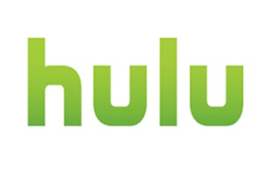
A deal between Disney and Comcast will immediately pass full control of Hulu operations over to Disney and give Comcast the option to hand over its remaining 33% stake in the streaming service in 2024. Disney will pay for content from Hulu until that date, and will do so at a higher rate for NBC channels.
CNBC 5/14/19
https://www.cnbc.com/2019/05/14/comcast-has-agreed-to-sell-its-stake-in-hulu-in-5-years.html

