Comcast Invests in Esports Venture With SK Telecom
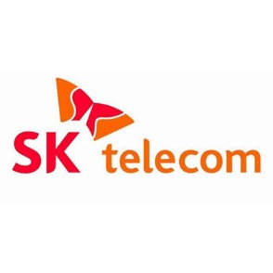
Comcast is teaming up with SK Telecom to create an esports venture controlled by the South Korean company that will support gaming teams, sell merchandise and pursue sponsorships and broadcast rights. The cable company will become the second largest shareholder in Seoul-based SK Telecom CS T1, which will establish a Los Angeles office in addition to its primary location.
ZDNet 10/11/19
https://www.zdnet.com/article/sk-telecom-and-comcast-form-joint-esports-company/

