Comcast is Preparing Video Service Called "Watchable"
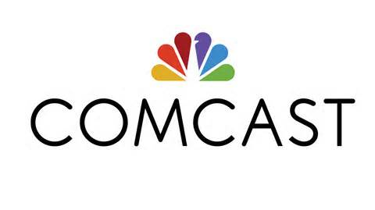
Comcast will soon launch a video platform with content from NBC Sports, Vox, Buzzfeed, Vice, Refinery29 and other partners, a report states. The platform, called Watchable, will compete against the online-video dominance of YouTube and Facebook and open up a digital-advertising revenue stream. Watchable will be available through Comcast's set-top boxes, as well as on the Web and mobile devices, reports indicate.
Business Insider 8/14/15
http://www.businessinsider.com/comcast-to-launch-digital-video-platform-watchable-2015-8

