Comcast Makes Internet Essentials Speed 50 Mbps
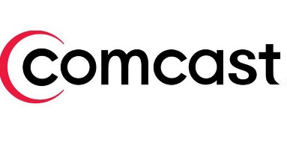
Comcast will speed up data for the users in its Internet Essentials subsidy program, offering 50 megabits per second starting March 1. The cable company also said that it will offer $3.5 million grants to several partners as part of a commitment to narrow the digital divide.
VentureBeat 2.2.21
https://venturebeat.com/2021/02/02/comcast-commits-3-5-million-to-digital-equity-causes/

