Comcast's NBCUniversal Acquires DreamWorks
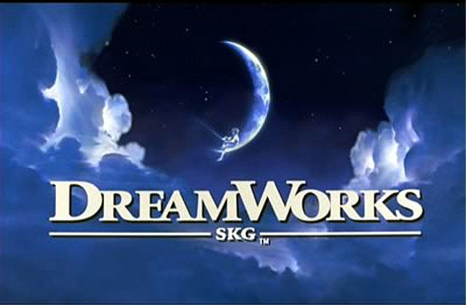
Comcast's NBCUniversal has announced that it has acquired DreamWorks Animation in a $3.8 billion deal. DreamWorks franchises include "Shrek," "Madagascar" and "How To Train Your Dragon." DreamWorks shareholders will receive $41 per share in cash, with the sale slated to close by the end of the year.
Broadcasting & Cable 4/28/16
http://www.broadcastingcable.com/news/currency/dreamworks-animation-bought-comcast-s-nbcuniversal/156025

