Comcast Selling $18 Streaming TV Service
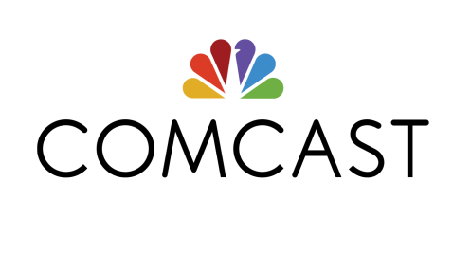
Comcast would rather you buy a lot of TV from them, not a little. But if you want to buy a little, they’ll sell you that, too: The biggest pay TV provider in the country is starting to sell an $18-a-month “skinny bundle” which gives you a handful of TV channels, primarily the big broadcasters. Comcast is marketing this one to a subset of its customers — those who use it for internet but aren’t paying it for TV.
Recode 9.27.17
https://www.recode.net/2017/9/27/16374620/comcast-streaming-tv-18-month

