Comcast Sets April Debut for NBCU Streaming Service
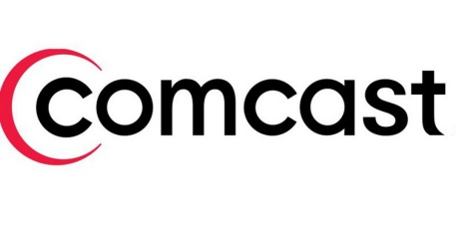
Comcast offered more details about NBCUniversal's upcoming streaming service, saying it will debut in April and consist mostly of acquired, rather than original, programming. Steve Burke, NBCU's CEO, pointed to "The Office" -- which NBCU will acquire exclusively in 2021 -- as an example of a tentpole show on the service, noting that the sitcom accounts for 5% of Netflix's total "volume."
The Hollywood Reporter 7/25/19
https://www.hollywoodreporter.com/news/nbcu-ceo-targets-streaming-service-april-office-as-tentpole-1226602

