Competition to Heat Up As Digital Giants Move Into TV Landscape
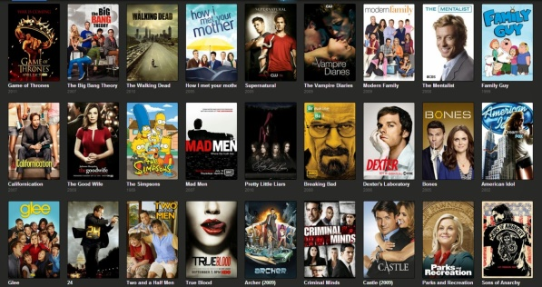
Facebook, Google and Apple are gearing up to make their move into TV, creating even more competition in a crowded television marketplace. These companies are willing to make big investments in original content to break into the industry, which is expected to have over 500 scripted series this year alone.
The New York Times 8/20/17
https://www.nytimes.com/2017/08/20/business/media/tv-marketplace-apple-facebook-google.html?WT.mc_id=SmartBriefs-Newsletter&WT.mc_ev=click&ad-keywords=smartbriefsnl
Image source:
https://www.howtomash.com/wp-content/uploads/2016/12/5fdfb649fee90b18ac9535bfc66ca5b7.jpg

