Connected Car Commerce Is Ready To Rev Up
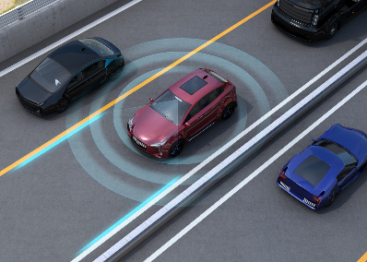
Connected car commerce is poised for growth due to the rise in connected vehicles, new in-vehicle video and gaming capabilities from the likes of Google and Amazon, and automakers partnering with financial firms to offer in-car payments. Brands can expect to see new voice and other search opportunities specific to vehicle systems and new in-vehicle ad formats and platforms tied to demographic, location and other data points.
Insider Intelligence 10/13/23
https://www.insiderintelligence.com/content/entertainment-commerce-will-take-off-connected-cars
Image credit:
https://www.wikidriver.es/wp-content/uploads/2020/03/Connected-cars-3-1536x1097.jpg

