Connected Device Use Soars In Broadband Homes
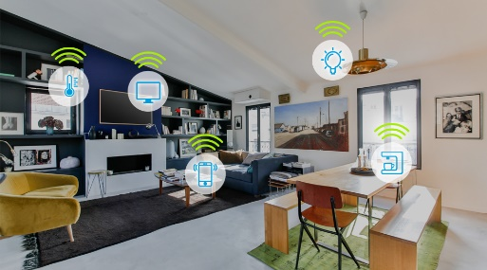
The average broadband home in the US has 14.5 connected devices, compared to 9.6 in 2017, Parks Associates reports in its latest survey. Parks found that 80% subscribe to at least one streaming service, and 36% either have online gaming accounts or are testing them.
TV Tech 1.6.22
https://www.tvtechnology.com/news/ces-2022-us-broadband-homes-now-have-145-connected-devices
Image credit:
https://techeconomy.ng/wp-content/uploads/2018/10/smart-home-devices.jpg

