Edelman: Consumer Trust in Business, Media, Government Waning
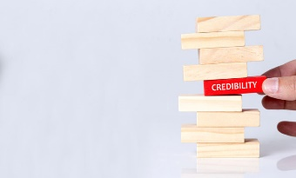
Consumers are increasingly skeptical of government and business leaders and the media and many believe that individuals within these groups are spreading falsehoods, according to Edelman's 2021 Trust Barometer. Individuals do, however, believe businesses are ethical and competent and "expect [them] to address today's challenges as rigorously as they pursue profits," according to report authors.
PRSAY 1/19/21
http://prsay.prsa.org/2021/01/19/reoport-amid-growing-mistrust-of-governments-and-media-business-must-provide-credible-information/
Image credit:
https://www.the-gma.com/wp-content/uploads/2017/01/brand-building-trust-credibility-shutterstock_509114425-780x470.jpg

