Consumers Cool On User-Generated Social Content
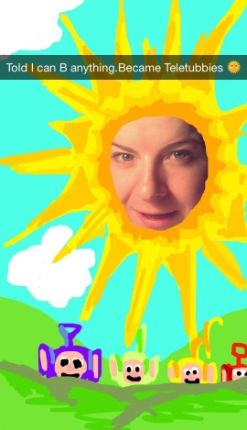
A Visual Objects' consumer survey shows that 75% of individuals are unlikely to use a company's branded hashtag in a post, 73% are not keen on creating branded videos and just 11% interacted with a social media hashtag campaign within the past three months. The survey also revealed reviews are the most popular form of user-generated content and people engage most frequently with Instagram, Snapchat and Facebook Stories.
Mobile Marketer 9.2.20
https://www.mobilemarketer.com/news/75-of-people-unlikely-to-use-branded-hashtags-survey-finds/584549/
Image credit:
https://images.summitmedia-digital.com/candy/images/2016/07/31/20160731-snapchat-8.jpg

