Consumers Use Smartphones to Watch Video at Home
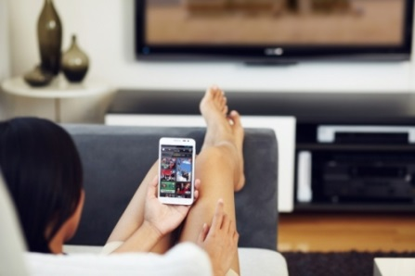
Consumers are using their smartphones to watch videos at home and would do so even more if they had larger data plans, per a Mobile Video: Exposed report. YouTube remains the top source for video content.
Rapid TV News (U.K.) 12/16/16
http://www.rapidtvnews.com/2016121645472/smartphones-transforming-the-television-experience.html#axzz4TJKpxY6z
Image source:
http://staging.gunnjerkens.com/shared/2012/07/Cell-Phone.jpeg

