Report: Consumers Value Authentic Content
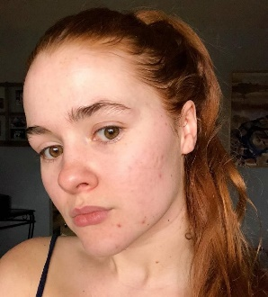
Most consumers (56%) prefer following normal people with authentic content, followed respectively by celebrities (34%), subject matter experts (29%) and social media stars (25%), while 86% search for authentic user-generated content prior to making a decision regarding a new product purchase, according to a Savanta survey of individuals in the US, Canada and four other countries. "We have moved into an era beyond traditional micro and macro influencers," said Ed Hill of Bazaarvoice.
PRWeek 8/17/21
https://www.prweek.com/article/1724983/celebrity-influencers-losing-touch
Image credit:
https://www.sarcasm.co/wp-content/uploads/2019/07/ipStKVXJgxl0kD2Vn8Pc-926x1024.jpg

