Cord-Cutting Trend Doubled in 2018
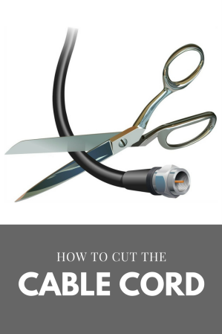
A recent report from Leichtman Research Group reveals that the leading 11 providers of pay TV in the US lost nearly 2.9 million accounts in 2018, almost twice as many as they lost in 2017. DISH and DIRECTV, the two biggest satellite carriers in the country, shed 2.36 million subscribers, and the six major cable providers dropped 910,000.
Multichannel News 3/6/19
https://www.multichannel.com/news/cord-cutting-doubled-in-2018-lrg-says
Image credit:
http://northshoreparent.com/wp-content/uploads/2017/03/quitting-cable.png

