Coronavirus Comms Require Timely, Accurate Information
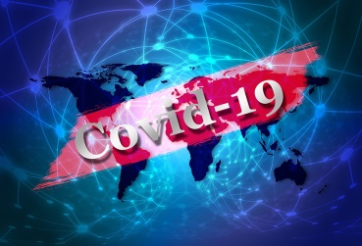
Misinformation about the coronavirus is reaching "infodemic" levels, and communications professionals are uniquely qualified to disseminate accurate details with the public. The Public Relations Society of America has issued guidelines for PR professionals that include an emphasis on transparency, truthfulness and timeliness and urged executives to use multiple sources that can be verified.
PRSAY 3.17.20
http://prsay.prsa.org/2020/03/16/how-communicators-can-help-inform-the-public-during-the-covid-19-crisis/
Image credit:
https://jagwire.augusta.edu/wp-content/uploads/sites/15/2020/03/COVID-19b.jpg

