Couples that Binge Together Stay Together
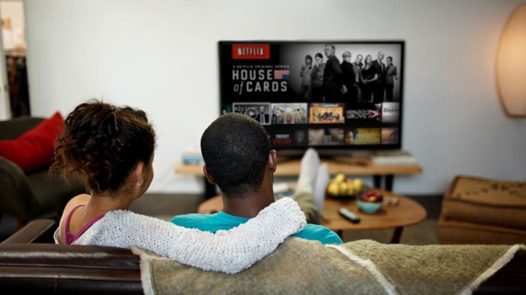
A study in the Journal of Social and Personal Relationships found that sharing media, including TV, movies and books, can help bring couples closer together, particularly those who don’t happen to share the same social circles. What they found is that sharing media, such as watching TV together, can help improve romantic relationships.
MediaLife 9.8.16
http://www.medialifemagazine.com/study-couples-binge-together-stay-together/

