CPB Prods TV Stations to Consolidate, Revamps Rural Grants
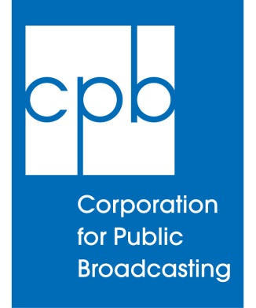
The new rules, recommended by a panel of station executives that worked on them over the past 18 months, include creation of a Healthy Network Initiative to encourage station collaboration and consolidation. The $5 million initiative would reward stations that become part of joint master-control hubs or consolidate under one executive management, Ted Krichels, s.v.p, system development, told the board.
Current.org 4.5.16
http://current.org/2016/04/cpb-prods-tv-stations-to-consolidate-revamps-rural-grants/

