CRB Announces New 5-year Rates For Streaming Royalties
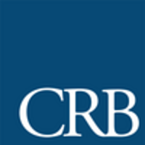
The Copyright Royalty Board announced plans to increase radio streaming rates from $0.18 per 100 songs streamed to $0.21 for 2021 to 2025. The National Association of Broadcasters has said it "is looking forward to reviewing the Board's opinion in detail" before determining what its next steps are.
Inside Radio (free content) 6.14.21
http://www.insideradio.com/free/crb-hikes-radio-s-streaming-rates-judges-reject-nab-push-to-charge-less-for-simulcasts/article_d5e068b2-ccdd-11eb-84c6-7307ce224add.html

