Creditors Support iHeart Ch. 11 Plan; Liberty Might Purchase
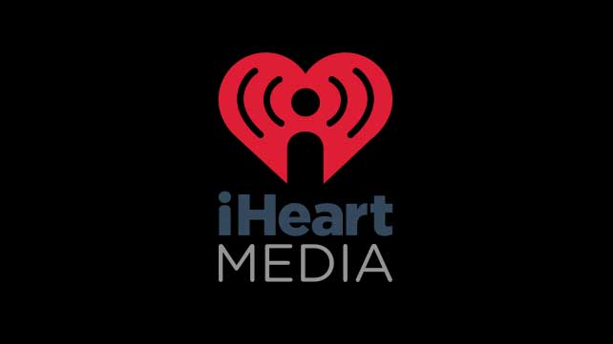
IHeartMedia has secured the votes needed from its creditors and shareholders to move forward with its Chapter 11 restructuring plan, which will lower the company's debt by $10.3 billion. Liberty Media is reportedly interested in a 35% stake of the company when it does emerge from bankruptcy.
Inside Radio (free content) 12/3/18
http://www.insideradio.com/iheart-secures-overwhelming-creditor-support-for-chap-reorg-plan/article_97a331bc-f70e-11e8-a32d-f3e64d291d21.html

