Critics Sound Off on Net Neutrality Compromise
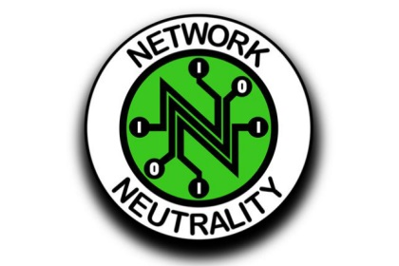
Senate Commerce Committee Chairman John Thune, R-S.D., and Sen. Roger Wicker, R-Miss., are promoting a bipartisan legislative compromise for net neutrality rules but are facing opposition from fellow Republicans. The compromise would prohibit blocking and throttling, while also limiting the Federal Communication Commission's future powers.
The Hill 2/11/17
http://thehill.com/policy/technology/319051-net-neutrality-fix-faces-hard-sell

