Crowds, Stoked by Trump’s Rhetoric, Increase Their Ire Toward the Press
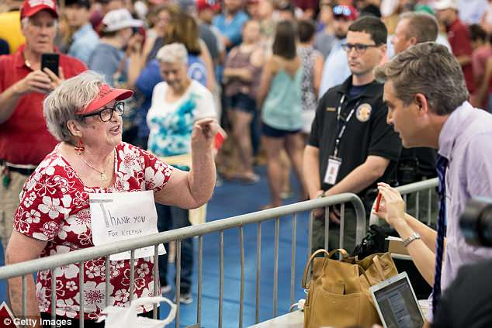
“Stop lying!” shouted a man in an American flag T-shirt, one of dozens of Trump supporters who hurled invective at the assembled press corps. Facing the reporters’ work space — and away from the stage where Mr. Trump was set to speak — they flashed middle fingers and chanted “CNN Sucks!” as Jim Acosta, a CNN White House correspondent, attempted to speak on-air.
The New York Times 8.1.18
https://www.nytimes.com/2018/08/01/business/media/trump-press-jim-acosta.html?rref=collection%2Fsectioncollection%2Fbusiness-media&utm_source=Listrak&utm_medium=Email&utm_term=Crowds+Increase+Their+Ire+Toward+The+Press&utm_campaign=TV+Groups+Slapped+With+Antitrust+Lawsuit
Image credit:
http://i.dailymail.co.uk/i/newpix/2018/06/26/06/4DA19BC900000578-5885917-image-a-69_1529992283187.jpg

