Customers Cutting Satellite TV Are Keeping Cable
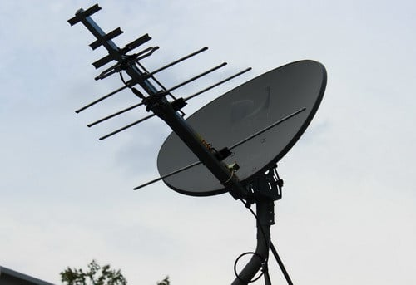
A large portion of the customers leaving DIRECTV and DISH are either keeping existing subscriptions to cable broadband or picking up new TV contracts, a Cowen report states. The report goes on to note that satellite subscribers had a 56/44 mix of cable and telco broadband in Cowen's latest survey.
Multichannel News 7/17/19
https://www.multichannel.com/news/cable-stealing-outsized-share-of-satellite-tv-quitters
Image credit:
http://removeandreplace.com/wp-content/uploads/2013/09/Satellite-Dish-With-HD-Antenna.jpg

