Dallas Station Recruits Skeptic for Climate Education Effort
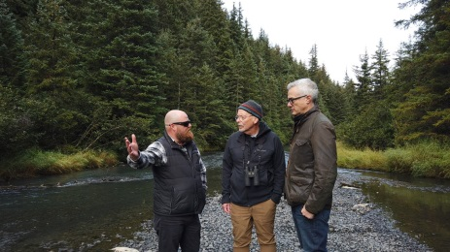
Dallas' WFAA TV is using "citizen-assisted reporting" to educate viewers about the effects of and importance of addressing climate change, recruiting a viewer who was skeptical about the issue and filming his journey of discovery. The program had Justin Fain, a roofing contractor from Texas, meet with climate experts and visit sites where the effects of climate change are most visible.
Poynter 11/18/19
https://www.poynter.org/business-work/2019/why-a-tv-station-recruited-climate-skeptics-to-go-on-a-fact-finding-road-trip/
Image credit:
https://media.wfaa.com/assets/WFAA/images/1ec4baef-ec71-414c-82eb-442eb79196ef/1ec4baef-ec71-414c-82eb-442eb79196ef_1140x641.jpg

