David Ellison Said To Enter Bid For Redstone Empire
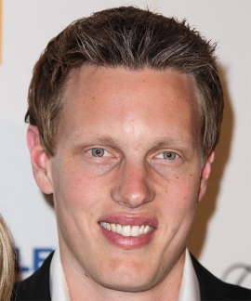
David Ellison has reportedly offered to acquire National Amusements from the Redstone family as part of his effort for his Skydance Media to gain control of Paramount Global, according to media reports. Along with private equity investors RedBird Capital Partners and KKR & Co., Skydance may then buy Paramount and take it private, reports say.
CNBC 1/24/24
https://www.cnbc.com/2024/01/24/david-ellisons-skydance-media-explores-buying-paramount-global.html
Image copyright:
https://hairstyles.thehairstyler.com/hairstyle_views/front_view_images/7371/original/David-Ellison.jpg

