‘Days of Our Lives’ Renewed for Season 56 at NBC
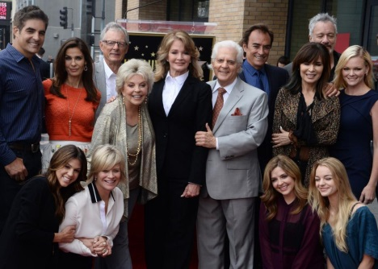
According to an individual with knowledge of the situation, the deal for the new season is not done yet but all signs point to it being closed soon. The news comes less than two weeks after it was reported that the entire cast of the series had been released from their contracts, which some took as a sign the show was coming to an end.
Variety Online 11.21.19
https://variety.com/2019/tv/news/days-of-our-lives-renewed-season-56-nbc-1203412297/
Image credit:
https://cdnph.upi.com/svc/sv/upi/3291483799544/2017/1/800eb7a7f78a590b2986214edd6383c9/Days-of-Our-Lives-future-unclear-after-Megyn-Kelly-daytime-chat-show-announcement.jpg

