Deepfake Ad Spots Raise Legal Concerns
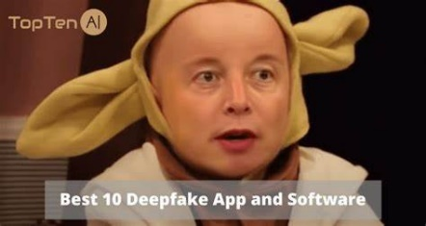
A growing number of commercials are using computer-generated images of celebrities to push products or services. Since the technology is relatively new, there are few laws governing the use of "deepfakes," which are gaining traction because they allow brands to create ads at a lower cost.
The Wall Street Journal 10.25.22
https://www.wsj.com/articles/deepfakes-of-celebrities-have-begun-appearing-in-ads-with-or-without-their-permission-11666692003
Image credit:
https://www.bing.com/images/search?view=detailV2&ccid=%2BSqD%2Fu%2Br&id=C4D6CAA9BF33FD15FDB9E88AB51130C1F40E43E0&thid=OIP.-SqD_u-rAqtl-_Jwpu4_BQHaD8&mediaurl=https%3A%2F%2Ftopten.ai%2Fwp-content%2Fuploads%2F2021%2F01%2Fdeepfake-app-and-software-review.png&cdnurl=https%3A%2F%2Fth.bing.com%2Fth%2Fid%2FR.f92a83feefab02ab65fbf270a6ee3f05%3Frik%3D4EMO9MEwEbWK6A%26pid%3DImgRaw%26r%3D0&exph=400&expw=750&q=deepfake+ads+musk&simid=608004809415025924&form=IRPRST&ck=77124D23E1824909E961C60F304985AD&selectedindex=1&ajaxhist=0&ajaxserp=0&vt=0&sim=11

