Infographic: 2022 Visual Design Trends
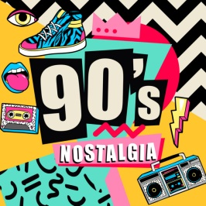
This infographic from 99designs by Vista offers insights about 12 graphic design trends for 2022 that marketers can incorporate into visuals for social media. Among the trends explored are "90s Nostalgia," "Daydream Doodles," "Escapism," "Parametric Patterns," and "Grunge Revival."
Social Media Today 12.5.21
https://www.socialmediatoday.com/news/12-graphic-design-trends-to-watch-in-2022-infographic/610959/

