Despite Aging Readership, the Sarasota Herald-Tribune is Thriving
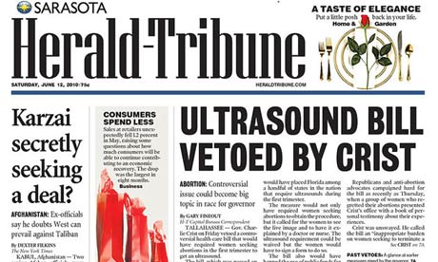
Far from dying, the paper is thriving. Print circulation is actually up by 4.5 percent since 2014, to 77,000 daily. Web traffic is up 35 percent jump since 2013. It’s warded off decline the old fashion way, by publishing first-rate journalism, with an emphasis on covering the diverse communities in its market and investigative stories.
MediaLife 4.21.16
http://www.medialifemagazine.com/a-paper-thats-defying-the-odds-in-florida/

